There are various Fiori Launchpad Configuration parameters. You may take a look at these parameters at [https://help.sap.com/saphelp_nw74/helpdata/en/61/07ee41f89a43c9af0aa279fe039cca/content.htm](http://help.sap.com/saphelp_nw74/helpdata/en/61/07ee41f89a43c9af0aa279fe039cca/content.htm)

I will mainly focus on personalization. Fiori Launchpad Personalization is enabled by default so you don’t need to change anything if you want personalization is on. FLP personalization is explained at [https://help.sap.com/saphelp_nw74/helpdata/en/83/86946aef974a9dad07e3029bcf40b7/content.htm](http://help.sap.com/saphelp_nw74/helpdata/en/83/86946aef974a9dad07e3029bcf40b7/content.htm)

Before all, I want to warn you about an important point that you should define your catalogs and groups in a well-organized manner. You should not duplicate your catalog tile entries especially. And alos, you need a good documentation of these defined catalog and groups. So after user custimization, you can address the application easily ad fix any problem.

**Do You Need FLP Personalization Off**

Actually, I don’t advise you make personalization off. Users hava a special group named as “My Home” and also they may be able to create new groups or manage existing groups. They may add/remove/rename or move tiles to groups, so they personalize their screen according to their usage or preferences. This is really an advantage that FLP provides for them.

**How You FLP Personalization Off**

There are a few methods to make personalization off  or change flp configuration parameters. First, you should take a look at below picture representing the presedence of different methods (or parameters defined in different locations)

[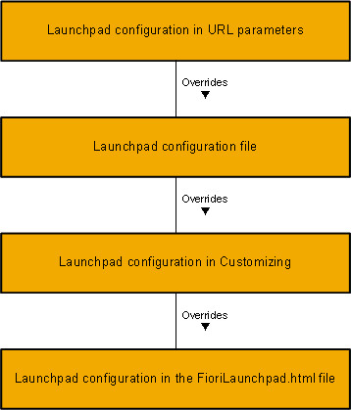](http://zyndanismanlik.com/wp-content/uploads/2019/09/p0.jpg)

Before going into details of these steps, let’s talk some about FioriLaunchpad.html which is a file delivered by SAP.

[metin içeren bir resim

Açıklama otomatik olarak oluşturuldu](http://zyndanismanlik.com/wp-content/uploads/2019/09/p1.jpg)

This is the entry point to Fiori Launchpad portal. All tiles and groups are displayed in a user friendly and mobile supported screen. An example screenshot is placed below.

[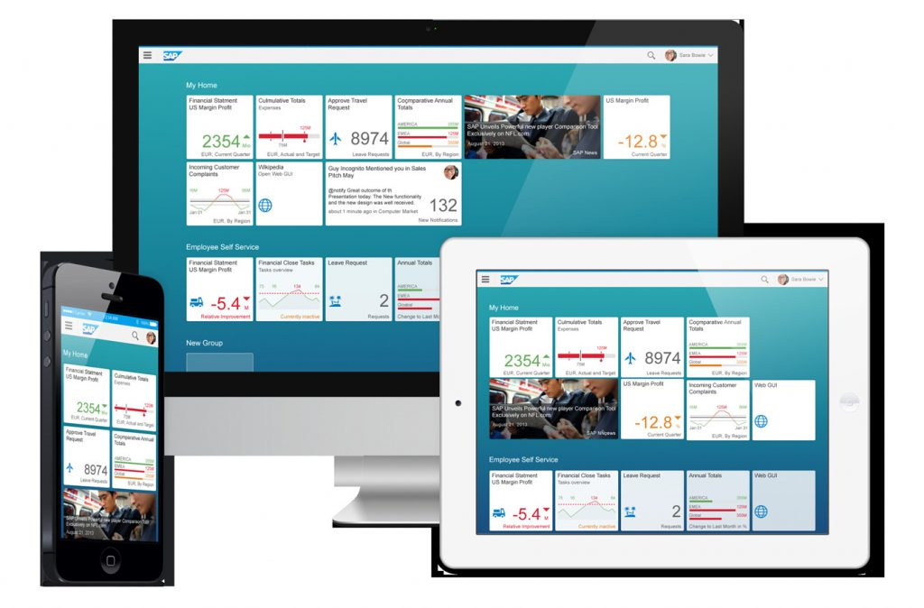](http://zyndanismanlik.com/wp-content/uploads/2019/09/p2.jpg)

Let’s talk about these methods from having less presedence to one having the most presedence.

**1.     FioriLaunchpad.html File Method**

This method has the least presedence so if the parameter defined in any other place, it will be overridden.

Below, there is a code segment in FioriLaunchpad.html. In this code segment, there is a parameter named as “**enablePersonalization**” which will enable/disable personalization. If you set this parameter true, then users may be able to personalize their FLP screens. Otherwise, they won’t be able to personalize their screens.

window[“sap-ushell-config”] = {

   “renderers”: {

       “fiori2” : {

           “componentData”: {

               “config”: {

**“enablePersonalization”: true**,

                   “enableTagFiltering”: false,

                   “enableSearch”: true,

                   “enableTilesOpacity”: false,

                   “enableSetTheme”: true,

                   “enableAccessibility”: true,

                   “enableHelp” : false,

                   “enableUserDefaultParameters”: true,

                   preloadLibrariesForRootIntent: false,

                   “enableBackGroundShapes”: false,

                   applications: {

                       “Shell-home” : {

                           enableActionModeMenuButton: true,

                           enableActionModeFloatingButton: true,

                           enableEasyAccess: true,

                           enableTileActionsIcon: false,

                           enableHideGroups: false,

                           enableLockedGroupsCompactLayout: false,

                           enableTilesOpacity: false

                       }….},…

**2.     Customizing**

This method is only available for ABAB-based systems. Parameters defined here in custimzation will override any parameters defined in the first method (FioriLaunchpad.html file)

SAP delivers some parameters with predefined values. You can look at these parameters in transaction /UI2/NWBC_CFG_SAP

You can override these predefined values or define new parameter values in transaction /UI2/NWBC_CFG_CUST. A list of parameters are:

[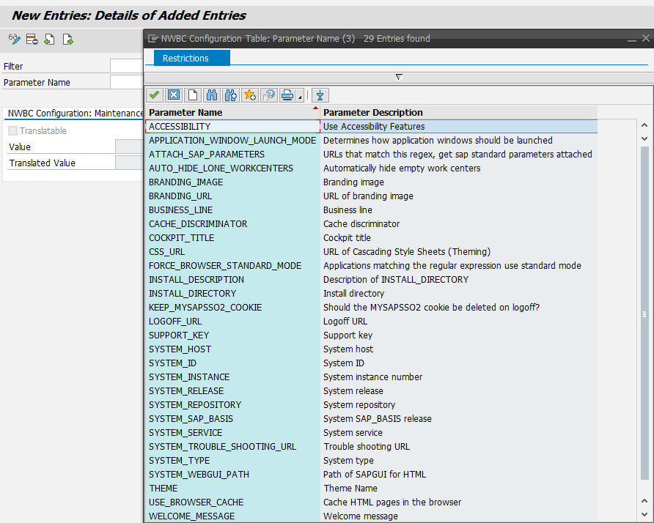](http://zyndanismanlik.com/wp-content/uploads/2019/09/p3.jpg)

**3.     Launchpad Configuration Files**

In FioriLaunchpad.html file, there is a code segment below.

[metin içeren bir resim

Açıklama otomatik olarak oluşturuldu](http://zyndanismanlik.com/wp-content/uploads/2019/09/p4.jpg)

There is a parameter **“sap-ushell-config-url”** with value default **undefined**.

By changing this parameter value to a json file containing enablePersonalization parameter, you can enable/disable personalization.

After set this parameter:

[metin içeren bir resim

Açıklama otomatik olarak oluşturuldu](http://zyndanismanlik.com/wp-content/uploads/2019/09/p5.jpg)

**4.     URL parameters**

There is a URL parameter **“sap-ushell-config-url”** which is path to a json file containing configuration information.

An example URL is:

https://<server>:<port>/sap/bc/ui5_ui5/ui2/ushell/shells/abap/FioriLaunchpad.html?sap-ushell-config-url=cfg/sap/PersonalizationOff.json

This method has the most presedence so it will override all others parameters defined in other locations.

Here I want to inform you about an important point. Since URL parameters are visible to users, you should encapsulate this url in some way. I don’t know whether you can achieve this with SAP Webdispacher, but I guess you may hiding this parameter or your internal url from users by using Apache Reverse Proxy. You should contact your system administrator

Finally I am adding a sample **PersonalizationOff.json** content:

{

    "documentation": {

        "description" : "This sample configuration disables the ability to personalize the homepage (e.g. move tiles, create groups)",

        "configURL" :"https://<host>:<port>/sap/bc/ui5_ui5/ui2/ushell/shells/abap/cfg/sap/PersonalizationOff.json",

        "startupURL" : "https://<server>:<port>/sap/bc/ui5_ui5/ui2/ushell/shells/abap/FioriLaunchpad.html?sap-client=<client>&sap-ushell-config-url=cfg/sap/PersonalizationOff.json",

        "localStartupURL" : "http://localhost:8080/sap/bc/ui5_ui5/ui2/ushell/shells/abap/FioriLaunchpad.html?sap-ushell-config-url=cfg/sap/PersonalizationOff.json"

    },

    "renderers": {

        "fiori2" : {

            "componentData": {

                "config": {

                    "enablePersonalization": false,

                    "enableTagFiltering": false,

                    "enableSetTheme": false,

                    "enableAccessibility": true,

                    "enableSendFeedback": false

                }

            }

        }

    }

}